Q1A: ANS:

select s.SalesOrderID, p.Name as [Product_Name],

ps.Name as [Product_SubCategory_Name],

pc.Name as [Product_Category_Name],

s.UnitPrice, s.UnitPriceDiscount,s.LineTotal

from Production.Product p

inner join Sales.SalesOrderDetail s

on p.ProductID=s.ProductID

inner join Production.ProductSubcategory ps

on p.ProductSubcategoryID=ps.ProductSubcategoryID

inner join Production.ProductCategory pc

on pc.ProductCategoryID=ps.ProductCategoryID

order by 2

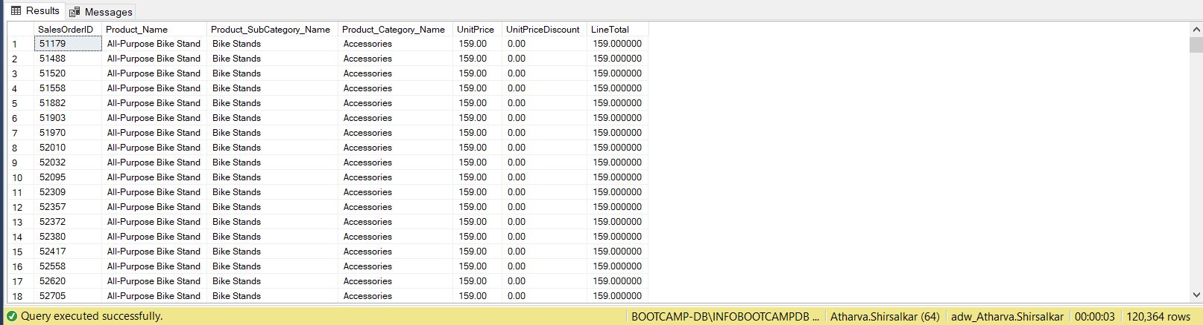

Q1B: ANS:

select p.ProductID, p.Name as [Product],

ps.ProductSubcategoryID, ps.Name as [ProductSubCategory],

pc.ProductCategoryID, pc.Name as [ProductCategory]

from Production.Product p

full join Production.ProductSubcategory ps

on p.ProductSubcategoryID=ps.ProductSubcategoryID

full join Production.ProductCategory pc

on pc.ProductCategoryID=ps.ProductCategoryID

order by 2

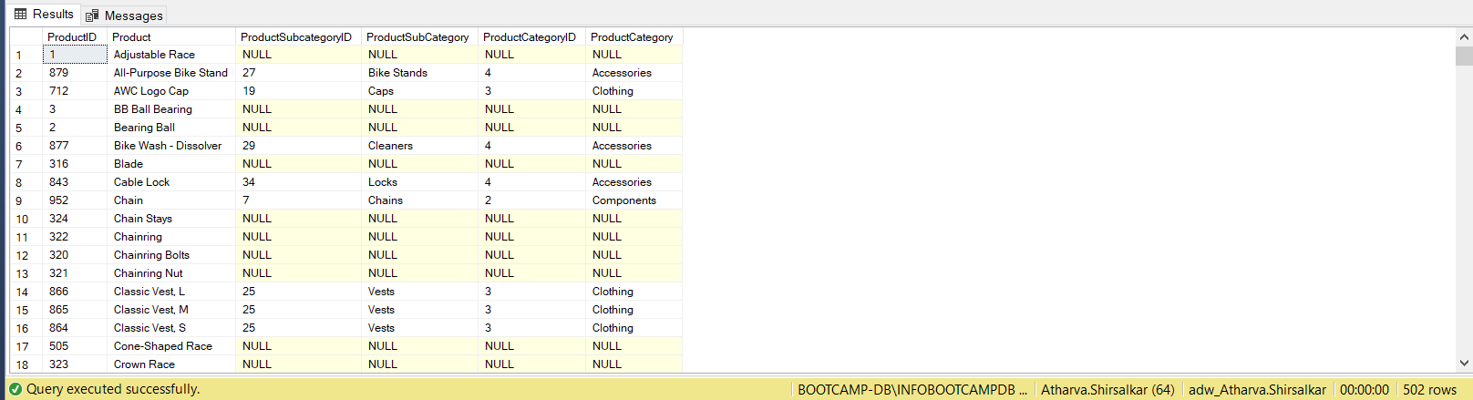

Q2: ANS:

select PC.Name as [Category name], SOH.OrderDate,

SUM(SOH.SubTotal) as [SubTotals]

from Production.ProductCategory AS PC

inner join Production.ProductSubcategory AS PSC

on PC.ProductCategoryID=PSC.ProductCategoryID

inner join Production.Product AS P

on PSC.ProductSubcategoryID=P.ProductSubcategoryID

inner join Sales.SalesOrderDetail AS SOD

on P.ProductID=SOD.ProductID

inner join Sales.SalesOrderHeader AS SOH

on SOD.SalesOrderID=SOH.SalesOrderID

group by PC.Name, SOH.OrderDate

having SOH.OrderDate between '2003-12-01' AND '2003-12-31'

Order by SOH.OrderDate

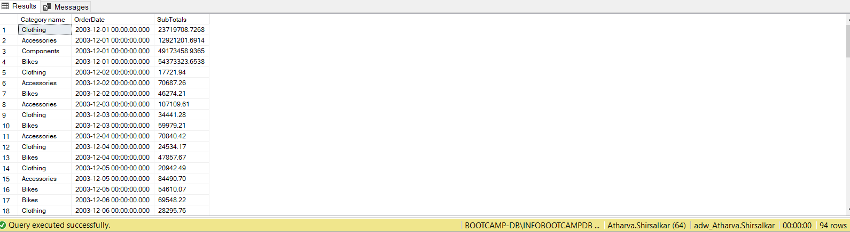

Q3: ANS:

select SOH.[SalesOrderID],SR.Name as [Sale Reason],

SR.[ReasonType], SOH.[ShipDate],

SOH.[SubTotal], SOH.[TaxAmt] "Tax Amount",

SOH.[Freight], SOH.[TotalDue]

from Sales.SalesOrderHeader SOH

inner join Sales.SalesOrderHeaderSalesReason SHR

on SOH.SalesOrderID=SHR.SalesOrderID

inner join Sales.SalesReason SR

on SR.SalesReasonID=SHR.SalesReasonID

where SR.Name NOT IN ('Quality','Manufacturer')

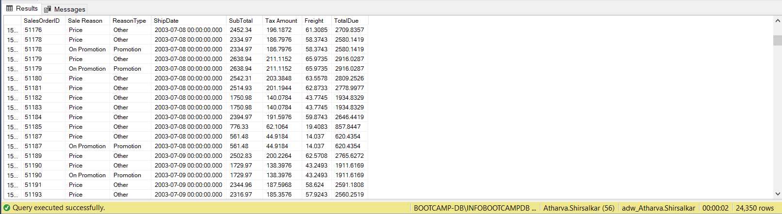

Q4: ANS:

select distinct(p.Name) as [Products that were sold <.45 DiscountPct]

from Production.Product p

inner join Sales.SpecialOfferProduct sop

on sop.ProductID=p.ProductID

inner join Sales.SpecialOffer sp

on sp.SpecialOfferID=sop.SpecialOfferID

where DiscountPct<=0.45 and p.Name not like 'R%'

Order by 1 desc

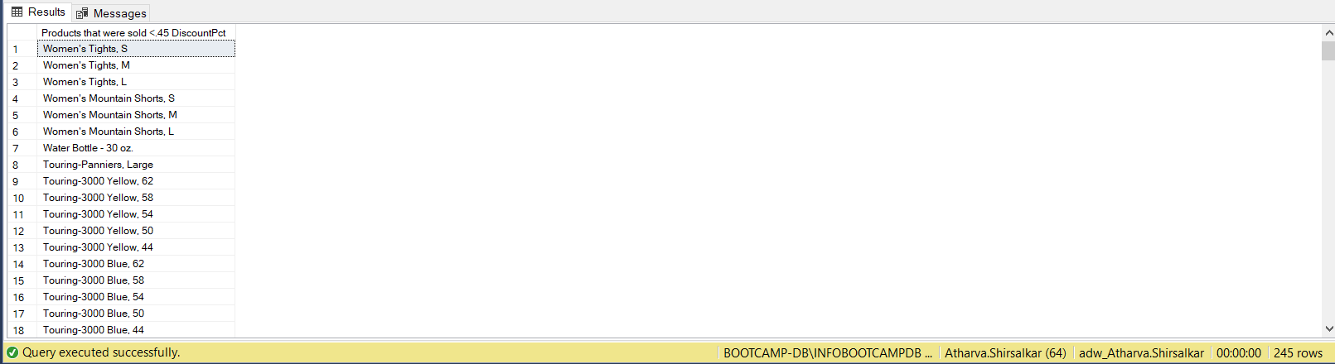

Q5: ANS:

select p.Name as [Product Name]

from Production.Product p

where p.Name like '%[^A-Za-z ]%'

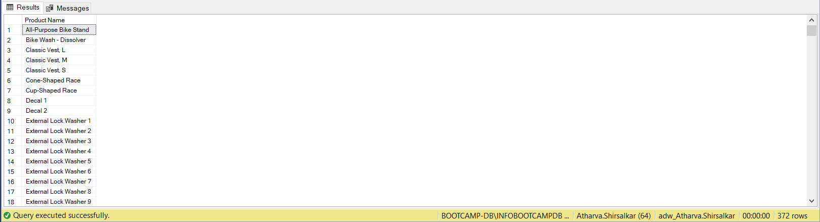

Q6: ANS:

select top 1 st.Name as [Province Name], tr.TaxRate,

tr.Name as [Tax Name]

from Sales.SalesTerritory st

inner join Person.StateProvince sp

on st.TerritoryID=sp.TerritoryID

inner join Sales.SalesTaxRate tr

on tr.StateProvinceID=sp.StateProvinceID

Order by 2 desc

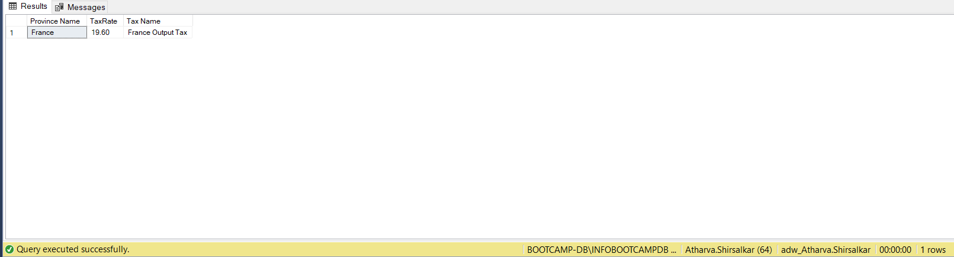

Q7: ANS:

select st.Name as [Location], pc.Name as [Category],

sum(sod.LineTotal) as [Revenue Generated]

from Sales.SalesTerritory st

inner join Sales.SalesOrderHeader soh

on st.TerritoryID=soh.TerritoryID

inner join Sales.SalesOrderDetail sod

on sod.SalesOrderID=soh.SalesOrderID

inner join Production.Product p

on p.ProductID=sod.ProductID

inner join Production.ProductSubcategory sc

on p.ProductSubcategoryID= sc.ProductSubcategoryID

inner join Production.ProductCategory pc

on pc.ProductCategoryID=sc.ProductCategoryID

group by st.Name, pc.Name

Order by 1

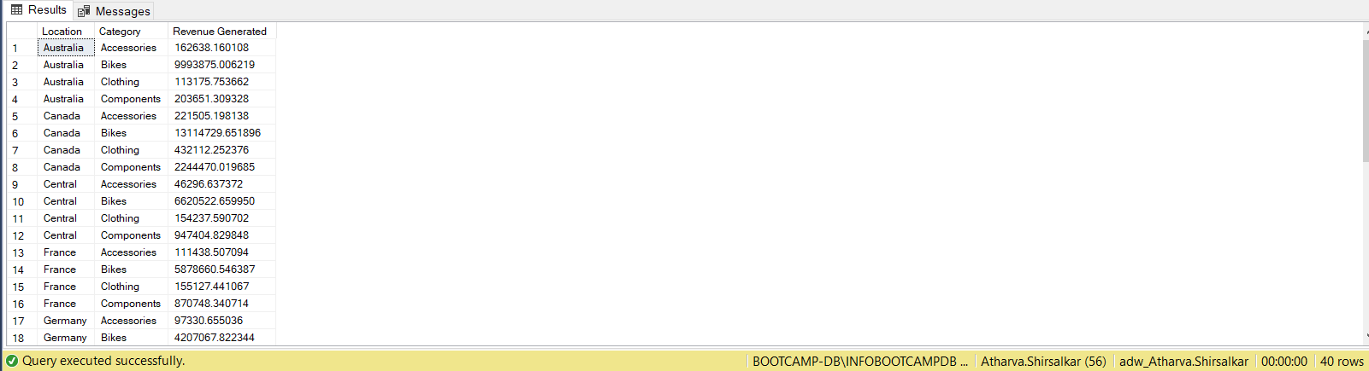

Q8: ANS:

with EMP AS

(

select (E.[EmployeeID]) AS "NO_OF_EMPLOYEE",

SP.SalesYTD AS SALES,

CASE

WHEN DATEDIFF(YYYY,E.[HireDate], GETDATE())< 15 THEN 'Less Than 15'

WHEN DATEDIFF(YYYY,E.[HireDate], GETDATE()) between 15 AND 18 THEN 'Ranges between 15-18'

ELSE 'Greater Than 18'

END AS [EXPERIENCE]

from HumanResources.Employee E

left join [Sales].[SalesPerson] SP

on SP.[SalesPersonID]=E.[EmployeeID]

)

select COUNT(NO_OF_EMPLOYEE) as [Number of Employeees],

EXPERIENCE, SUM(SALES) as [SalesDone]

from EMP

group by EXPERIENCE;

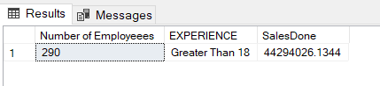

Q9: ANS:

select PC.Name as [Category name],

avg(SOD.OrderQty) as [Units Sold]

from Sales.SalesOrderDetail SOD

inner join Production.Product P

on P.ProductID=SOD.ProductID

inner join Production.ProductSubcategory PSC

on PSC.ProductSubcategoryID=P.ProductSubcategoryID

inner join Production.ProductCategory PC

on PC.ProductCategoryID=PSC.ProductCategoryID

inner join Sales.SalesOrderHeader SOH

on SOH.SalesOrderID=SOD.SalesOrderID

where OrderDate between '2003-04-01' AND '2003-05-31'

group by PC.Name;

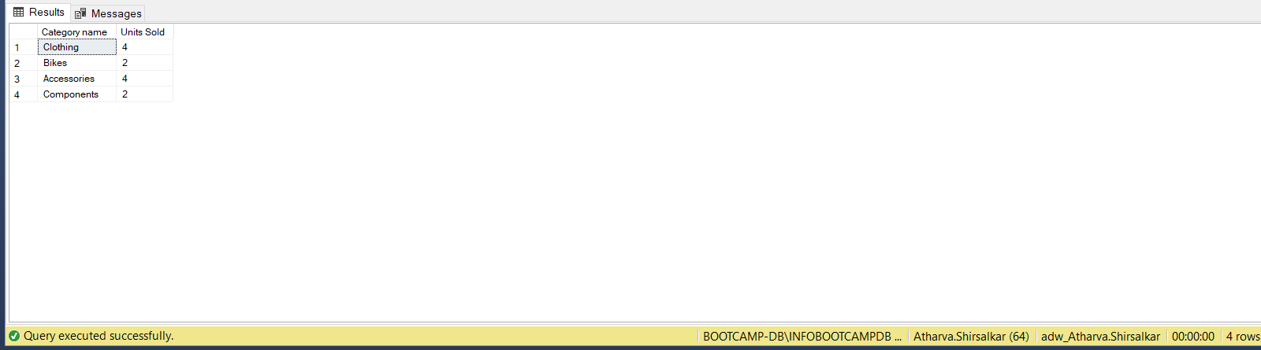

Q10A: ANS:

WITH CLOTHING AS

(

select SUM(SOD.OrderQty) [UNIT_SOLD],

PC.Name [CATEGORY],

DATEPART(MonTH,OrderDate) AS [Months],

DATEPART(Year,OrderDate) AS [Years]

from Sales.SalesOrderDetail SOD

inner join Production.Product P

on P.ProductID=SOD.ProductID

inner join Production.ProductSubcategory PSC

on PSC.ProductSubcategoryID=P.ProductSubcategoryID

inner join Production.ProductCategory PC

on PC.ProductCategoryID=PSC.ProductCategoryID

inner join Sales.SalesOrderHeader SOH

on SOH.SalesOrderID=SOD.SalesOrderID

where[OrderDate] between '2003-01-01' AND '2003-12-31'

AND PC.Name = 'Clothing'

group by PC.Name,DATEPART(MonTH,OrderDate),

DATEPART(Year,OrderDate)

),

BIKES AS

(

select SUM(SOD.OrderQty) [UNIT_SOLD],

PC.Name [CATEGORY],

DATEPART(MonTH,OrderDate) AS [Months],

DATEPART(Year,OrderDate) AS [Years]

from Sales.SalesOrderDetail SOD

inner join Production.Product P

on P.ProductID=SOD.ProductID

inner join Production.ProductSubcategory PSC

on PSC.ProductSubcategoryID=P.ProductSubcategoryID

inner join Production.ProductCategory PC

on PC.ProductCategoryID=PSC.ProductCategoryID

inner join Sales.SalesOrderHeader SOH

on SOH.SalesOrderID=SOD.SalesOrderID

where[OrderDate] between '2003-01-01' AND '2003-12-31'

AND PC.Name = 'Bikes'

group by PC.Name,DATEPART(MonTH,OrderDate),

DATEPART(Year,OrderDate)

)

select CLOTHING.Years, CLOTHING.Months,

CLOTHING.UNIT_SOLD AS ClothingSaleQTY,

BIKES.UNIT_SOLD AS BikesSaleQTY

from CLOTHING, BIKES

where CLOTHING.Months=BIKES.Months AND

CLOTHING.Years=BIKES.Years AND

CLOTHING.UNIT_SOLD<BIKES.UNIT_SOLD

Order by 2,1

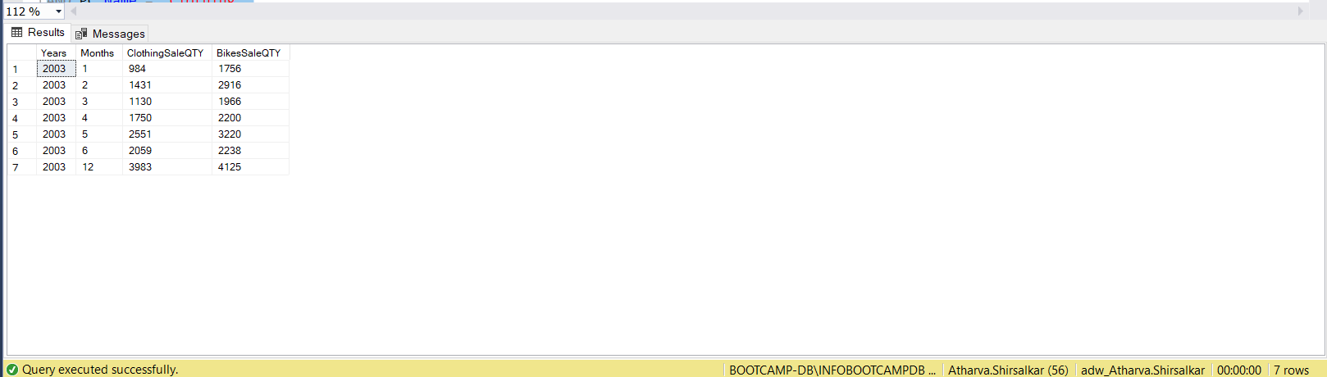

Q10B: ANS:

select LEFT(P.Name, 10) AS [Product Name Broken],

PD.Description

from Production.Product P

inner join Production.ProductModelProductDescriptionCulture PMPDC

on P.ProductModelID=PMPDC.ProductModelID

inner join Production.ProductDescription PD

on PD.ProductDescriptionID=PMPDC.ProductDescriptionID

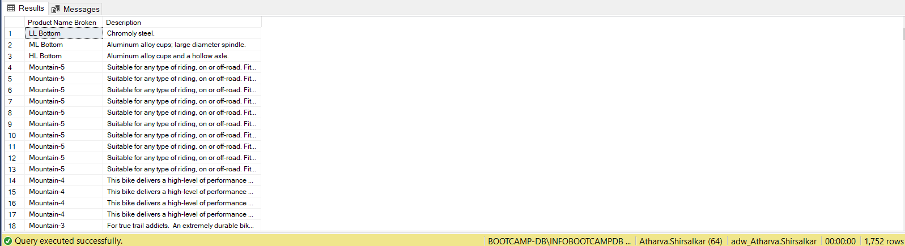

Q11: ANS:

Select LEFT(P.[Name], 10) AS "BROKEN PRODUCT NAME",

PD.[Description],

LEN(P.[Name])-10 AS "NO. OF CHAR. DELETED"

from Production.Product P

inner join [Production].[ProductModelProductDescriptionCulture] PMPDC

on P.[ProductModelID]=PMPDC.[ProductModelID]

inner join [Production].[ProductDescription] PD

on PD.[ProductDescriptionID]=PMPDC.[ProductDescriptionID]

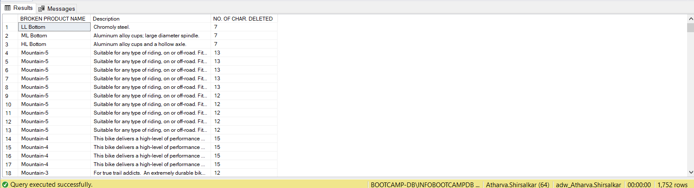

Q12: ANS:

select SUM(SOD.[OrderQty]) AS [Total Sale]

from HumanResources.Employee E

inner join Sales.SalesPerson SP

on SP.SalesPersonID=E.EmployeeID

inner join Sales.SalesOrderHeader SOH

on SOH.SalesPersonID=SP.SalesPersonID

inner join Sales.SalesOrderDetail SOD

on SOH.SalesOrderID=SOD.SalesOrderID

where E.[MaritalStatus]='M'

AND DATEDIFF(YEAR,E.[BirthDate], GETDATE()) between 40 and 50

AND SOH.[OrderDate] between '2003-07-01' AND '2003-09-30'

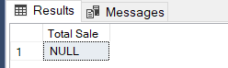

Q13: ANS:

with cte1 as(

select C.[CustomerID] AS [No of Customers],

COUNT (DISTINCT PC.[Name]) AS [Category]

from [Production].[ProductCategory] PC

inner join [Production].[ProductSubcategory] PSC

on PC.[ProductCategoryID]=PSC.[ProductCategoryID]

inner join [Production].[Product] P

on PSC.[ProductSubcategoryID]=P.[ProductSubcategoryID]

inner join [Sales].[SalesOrderDetail] SOD

on P.[ProductID]=SOD.[ProductID]

inner join [Sales].[SalesOrderHeader] SOH

on SOD.[SalesOrderID]=SOH.[SalesOrderID]

inner join [Sales].[Customer] C

on C.[CustomerID]=SOH.[CustomerID]

group by C.[CustomerID]

)

select COUNT([No of Customers]) as [Count of customers]

from cte1

where Category = 4

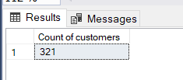

Q14: ANS:

select PC.[Name] AS [Category],

SUM(SOD.[LineTotal])AS [Total Sales],

ROUND (SUM(SOD.[LineTotal])*100/(select SUM(SOD.[LineTotal]) AS [BIG TOTAL]

from [Sales].[SalesOrderDetail] SOD

inner join[Sales].[SalesOrderHeader] SOH

on SOD.[SalesOrderID]=SOH.[SalesOrderID]

where SOH.[OrderDate] between '2004-06-01' AND '2004-06-30') ,2)

AS [PERCENTS]

from [Sales].[SalesOrderDetail] SOD

inner join [Production].[Product] P

on P.[ProductID]=SOD.[ProductID]

inner join [Production].[ProductSubcategory] PSC

on PSC.[ProductSubcategoryID]=P.[ProductSubcategoryID]

inner join [Production].[ProductCategory] PC

on PC.[ProductCategoryID]=PSC.[ProductCategoryID]

inner join [Sales].[SalesOrderHeader] SOH

on SOH.[SalesOrderID]=SOD.[SalesOrderID]

where SOH.[OrderDate] between '2004-06-01' AND '2004-06-30'

AND PC.[Name] IN ('Accessories','Bikes')

group by PC.[Name]

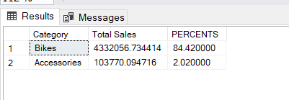

Q15: ANS:

select PC.[Name] AS Category,

SUM(SOD.[LineTotal])AS "Total Sales",

ROUND(SUM(SOD.[LineTotal])*100/

(select SUM(SOD.[LineTotal]) AS BIG_TOTAL

from [Sales].[SalesOrderDetail] SOD

inner join[Sales].[SalesOrderHeader] SOH

on SOD.[SalesOrderID]=SOH.[SalesOrderID]

where SOH.[OrderDate] between '2003-04-01' AND '2003-06-30'),2)

AS PERCENTS

from [Sales].[SalesOrderDetail] SOD

inner join [Production].[Product] P

on P.[ProductID]=SOD.[ProductID]

inner join [Production].[ProductSubcategory] PSC

on PSC.[ProductSubcategoryID]=P.[ProductSubcategoryID]

inner join [Production].[ProductCategory] PC

on PC.[ProductCategoryID]=PSC.[ProductCategoryID]

inner join [Sales].[SalesOrderHeader] SOH

on SOH.[SalesOrderID]=SOD.[SalesOrderID]

where SOH.[OrderDate] between '2003-04-01' AND '2003-06-30'

group by PC.[Name]

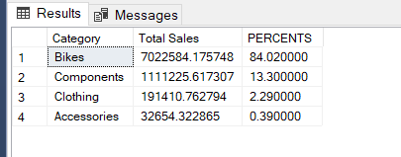

Q16: ANS:

select top 1 PC.[Name] AS "Product category",

MAX(SOD.[OrderQty]) AS "Maximum products Sold",

MIN(SOD.[OrderQty]) AS "Minimum products Sold",

MAX(SOD.[OrderQty])-MIN(SOD.[OrderQty]) AS "Diff between Max & Min"

from [Sales].[SalesOrderDetail] SOD

inner join [Production].[Product] P

on P.[ProductID]=SOD.[ProductID]

inner join [Production].[ProductSubcategory] PSC

on PSC.[ProductSubcategoryID]=P.[ProductSubcategoryID]

inner join [Production].[ProductCategory] PC

on PC.[ProductCategoryID]=PSC.[ProductCategoryID]

inner join [Sales].[SalesOrderHeader] SOH

on SOH.[SalesOrderID]=SOD.[SalesOrderID]

where SOH.[OrderDate] between '2003-01-01' AND '2003-12-31'

group by PC.[Name]

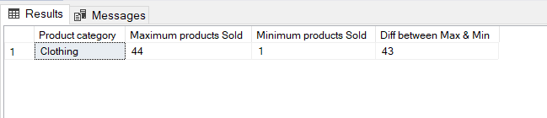

Q17: ANS:

--With INTERSECT

select PSC.[Name] as [NAME OF SUB CAT]

from [Production].[ProductCategory] PC

inner join [Production].[ProductSubcategory] PSC

on PC.[ProductCategoryID]=PSC.[ProductCategoryID]

inner join [Production].[Product] P

on PSC.[ProductSubcategoryID]=P.[ProductSubcategoryID]

inner join [Sales].[SalesOrderDetail] SOD

on P.[ProductID]=SOD.[ProductID]

inner join [Sales].[SalesOrderHeader] SOH

on SOD.[SalesOrderID]=SOH.[SalesOrderID]

where (DATEPART(MM, SOH.[OrderDate]) = 1 AND DATEPART(YY, SOH.[OrderDate])=2003)

AND PC.[Name] = 'Clothing'

group by PSC.[Name]

INTERSECT

select PSC.[Name] "NAME_OF_SUB_CAT"

from [Production].[ProductCategory] PC

inner join [Production].[ProductSubcategory] PSC

on PC.[ProductCategoryID]=PSC.[ProductCategoryID]

inner join [Production].[Product] P

on PSC.[ProductSubcategoryID]=P.[ProductSubcategoryID]

inner join [Sales].[SalesOrderDetail] SOD

on P.[ProductID]=SOD.[ProductID]

inner join [Sales].[SalesOrderHeader] SOH

on SOD.[SalesOrderID]=SOH.[SalesOrderID]

where (DATEPART(MM, SOH.[OrderDate]) = 2 AND DATEPART(YY, SOH.[OrderDate])=2004) AND PC.[Name] = 'Clothing'

group by PSC.[Name]

Order by PSC.[Name];

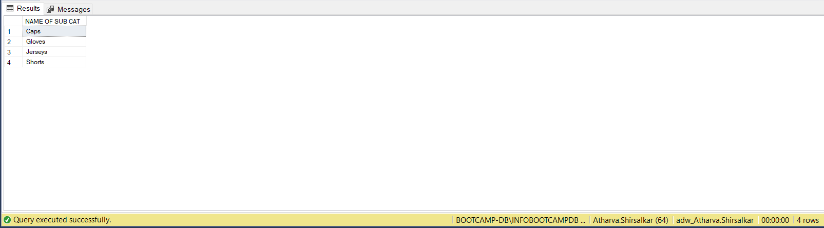

--Without INTERSECT

WITH TABLE1 AS (

select DISTINCT PSC.[Name] as pscname1

from [Production].[ProductCategory] PC

inner join [Production].[ProductSubcategory] PSC

on PC.[ProductCategoryID]=PSC.[ProductCategoryID]

inner join [Production].[Product] P

on PSC.[ProductSubcategoryID]=P.[ProductSubcategoryID]

inner join [Sales].[SalesOrderDetail] SOD

on P.[ProductID]=SOD.[ProductID]

inner join [Sales].[SalesOrderHeader] SOH

on SOD.[SalesOrderID]=SOH.[SalesOrderID]

where (DATEPART(MM, SOH.[OrderDate]) = 1 AND DATEPART(YY, SOH.[OrderDate])=2003)

AND PC.[Name] = 'Clothing'

),

TABLE2 AS

(

select DISTINCT PSC.[Name] as pscname2

from [Production].[ProductCategory] PC

inner join [Production].[ProductSubcategory] PSC

on PC.[ProductCategoryID]=PSC.[ProductCategoryID]

inner join [Production].[Product] P

on PSC.[ProductSubcategoryID]=P.[ProductSubcategoryID]

inner join [Sales].[SalesOrderDetail] SOD

on P.[ProductID]=SOD.[ProductID]

inner join [Sales].[SalesOrderHeader] SOH

on SOD.[SalesOrderID]=SOH.[SalesOrderID]

where (DATEPART(MM, SOH.[OrderDate]) = 2 AND DATEPART(YY, SOH.[OrderDate])=2004)

AND PC.[Name] = 'Clothing'

)

select pscname1 AS [SubcategoryName]

from TABLE1 T1

join TABLE2 T2

on T1.pscname1=T2.pscname2

Order by pscname1

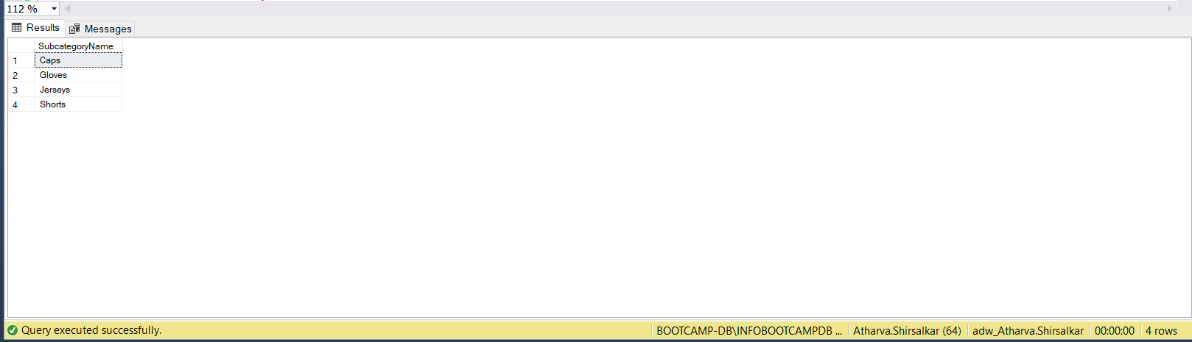

Q18: ANS:

WITH PCT AS(

SELECT PC.[Name] "Product_category",

P.[Name] "Product_name",

AVG(SOD.[LineTotal]) "avg_sales"

FROM [Production].[ProductCategory] PC

INNER JOIN [Production].[ProductSubcategory] PSC

ON PC.[ProductCategoryID]=PSC.[ProductCategoryID]

INNER JOIN [Production].[Product] P

ON PSC.[ProductSubcategoryID]=P.[ProductSubcategoryID]

INNER JOIN [Sales].[SalesOrderDetail] SOD

ON P.[ProductID]=SOD.[ProductID]

INNER JOIN [Sales].[SalesOrderHeader] SOH

ON SOD.[SalesOrderID]=SOH.[SalesOrderID]

WHERE YEAR(SOH.[OrderDate]) = 2003

GROUP BY PC.[Name], P.[Name]

)

SELECT Product_category,

Product_name,

avg_sales

FROM PCT

WHERE avg_sales IN (SELECT MIN(avg_sales) AS minimun_avg_sales

FROM PCT

GROUP BY Product_category

)

ORDER BY Product_category

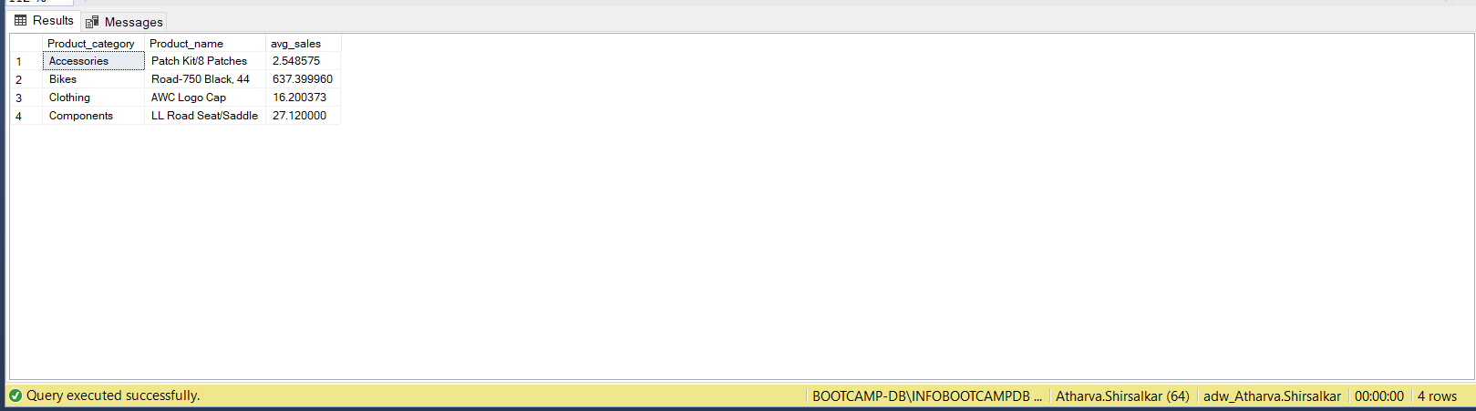

Q19A: ANS:

SELECT DISTINCT TOP 25 P.ProductID

INTO CustomProduct_ID_atharvashirsalkar

FROM Production.Product P

INNER JOIN Sales.SalesOrderDetail SOD

ON SOD.[ProductID]=P.[ProductID]

SELECT * FROM CustomProduct_ID_atharvashirsalkar

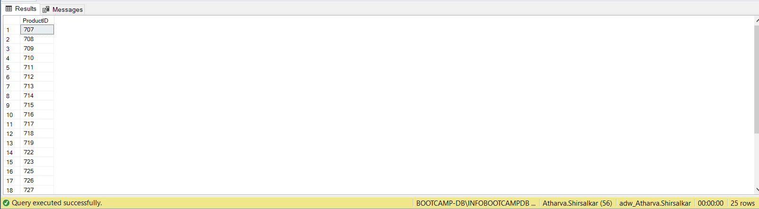

Q19B: ANS:

ALTER TABLE CustomProduct_ID_atharvashirsalkar

ADD ProductName VARCHAR(200)

SELECT * FROM CustomProduct_ID_atharvashirsalkar

UPDATE CustomProduct_ID_atharvashirsalkar

SET CustomProduct_ID_atharvashirsalkar.ProductName = P.Name

FROM [Production].[Product] AS P

INNER JOIN CustomProduct_ID_atharvashirsalkar CPAS

ON CPAS.[ProductID]=P.[ProductID]

SELECT * FROM [dbo].CustomProduct_ID_atharvashirsalkar

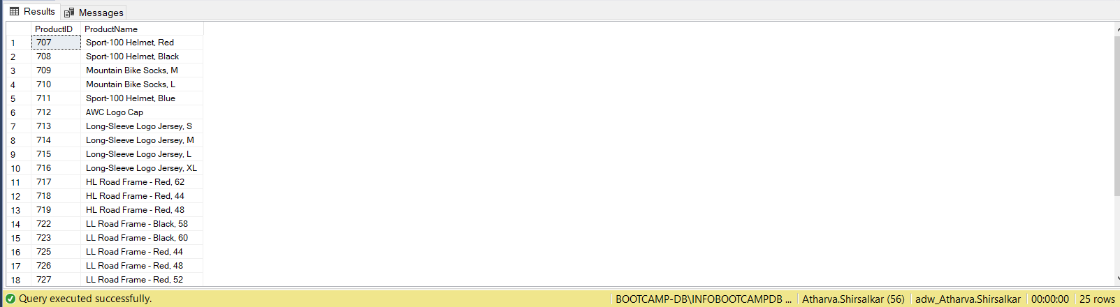

Q20: ANS:

SELECT *

INTO SalesOrderDetail_atharvashirsalkar

FROM Sales.SalesOrderDetail SOD

WHERE SOD.[OrderQty] <= 10 OR SOD.[OrderQty] >= 30

SELECT * FROM SalesOrderDetail_atharvashirsalkar;

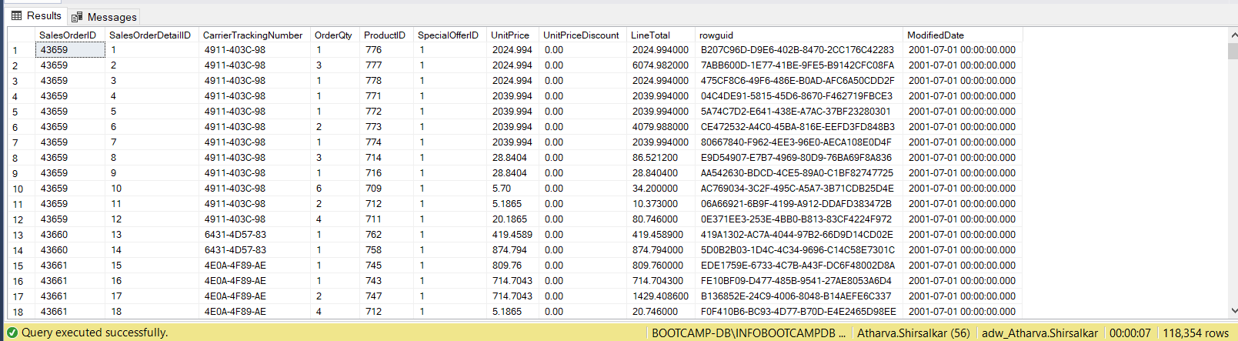

Q21: ANS:

WITH cte1 AS (

SELECT PC.[ProductCategoryID] CategoryID,

PSC.[ProductSubcategoryID] SubCategoryID,

PC.[Name] Category,

PSC.[Name] SubCategory,

SUM(SOD.[LineTotal]) as TotalRev2003

FROM [Production].[ProductCategory] PC

INNER JOIN [Production].[ProductSubcategory] PSC

ON PC.[ProductCategoryID] = PSC.[ProductCategoryID]

INNER JOIN [Production].[Product] P

ON P.[ProductSubcategoryID] = PSC.[ProductSubcategoryID]

INNER JOIN [Sales].[SalesOrderDetail] SOD

ON SOD.[ProductID] = P.[ProductID]

INNER JOIN [Sales].[SalesOrderHeader] SOH

ON SOD.[SalesOrderID] = SOH.[SalesOrderID]

WHERE YEAR(SOH.[OrderDate]) = 2003

GROUP BY PC.[ProductCategoryID], PSC.[ProductSubcategoryID], PC.[Name], PSC.[Name]

),

cte2 AS

(

SELECT PC.[ProductCategoryID] CategoryID,

PSC.[ProductSubcategoryID] SubCategoryID,

PC.[Name] Category,

PSC.[Name] SubCategory,

SUM(SOD.[LineTotal]) as TotalRev2004

FROM [Production].[ProductCategory] PC

INNER JOIN [Production].[ProductSubcategory] PSC

ON PC.[ProductCategoryID] = PSC.[ProductCategoryID]

INNER JOIN [Production].[Product] P

ON P.[ProductSubcategoryID] = PSC.[ProductSubcategoryID]

INNER JOIN [Sales].[SalesOrderDetail] SOD

ON SOD.[ProductID] = P.[ProductID]

INNER JOIN [Sales].[SalesOrderHeader] SOH

ON SOD.[SalesOrderID] = SOH.[SalesOrderID]

WHERE YEAR(SOH.[OrderDate]) = 2004

GROUP BY PC.[ProductCategoryID], PSC.[ProductSubcategoryID], PC.[Name], PSC.[Name]

)

SELECT cte1.CategoryID,

cte1.SubCategoryID,

cte1.Category,

cte1.SubCategory,

TotalRev2003 "Total Revenue Generated in 2003",

TotalRev2004 "Total Revenue Generated in 2004"

INTO SalesDetails_atharvashirsalkar

FROM cte1

LEFT JOIN cte2

ON cte1.SubCategoryID = cte2.SubCategoryID

SELECT*FROM SalesDetails_atharvashirsalkar

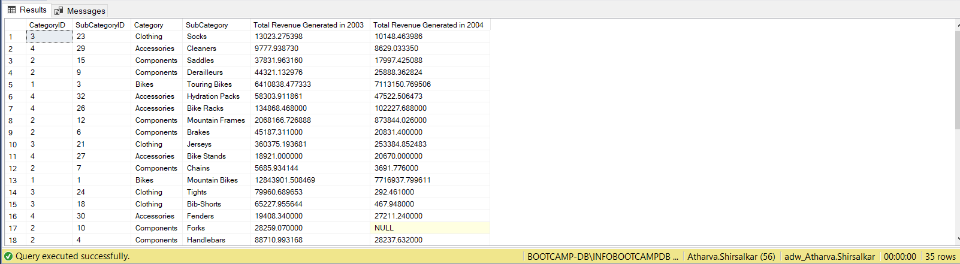

Q22A: ANS:

SELECT * INTO Employee_atharvashirsalkar

FROM [HumanResources].[Employee]

ALTER TABLE Employee_atharvashirsalkar

ADD SumOfSalary INT

UPDATE Employee_atharvashirsalkar

SET Employee_atharvashirsalkar.SumOfSalary = SP.[SalesYTD]

FROM [Sales].[SalesPerson] SP

INNER JOIN Employee_atharvashirsalkar EAS

ON SP.[SalesPersonID]=EAS.[EmployeeID]

SELECT * FROM Employee_atharvashirsalkar

WHERE SumOfSalary IS NOT NULL

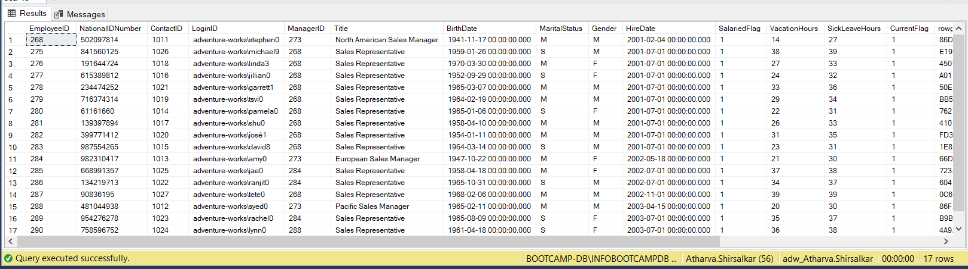

Q22B: ANS:

UPDATE Employee_atharvashirsalkar

SET SumOfSalary = CASE Gender

WHEN 'M' THEN SumOfSalary+(SumOfSalary*0.17)

WHEN 'F' THEN SumOfSalary+(SumOfSalary*0.20)

ELSE SumOfSalary

END

WHERE Gender IN ('M','F')

SELECT*FROM Employee_atharvashirsalkar

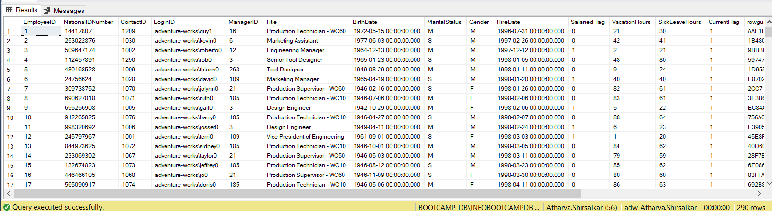

Q23: ANS:

SELECT [ProductID],

(REPLACE(REPLACE([ProductName],'-',''),',','')) AS [Replaced SpecialChars]

FROM [dbo].[CustomProduct_ID_atharvashirsalkar]

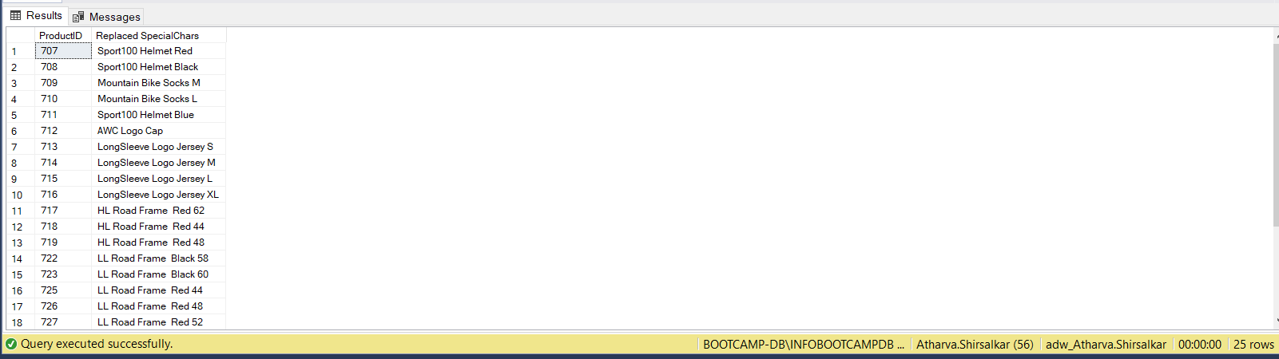

Q24: ANS:

SELECT * INTO SalesOrderHeader_atharvashirsalkar

FROM [Sales].[SalesOrderHeader]

With cte1 as

(

Select *,

row_number() over(order by SalesOrderID) as [Row Num]

from SalesOrderHeader_atharvashirsalkar

)

delete from cte1

where [Row Num]%100 = 0

select *from SalesOrderHeader_atharvashirsalkar

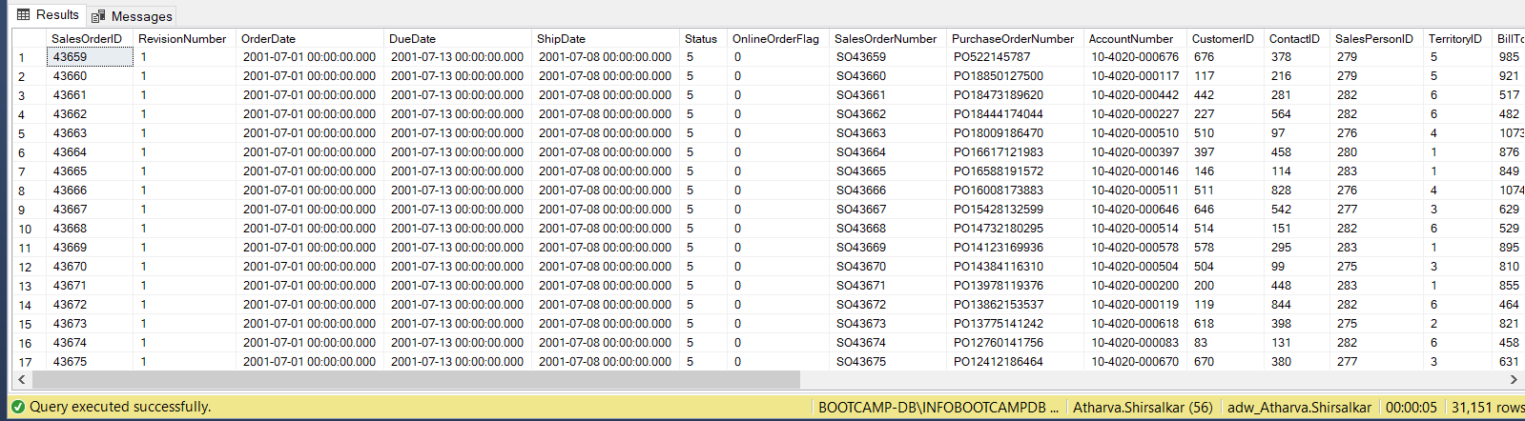

Q25: ANS:

with cte2 as(

select ProductID,

row_number() over (partition by ProductID order by ProductID) as [Row Num]

from [dbo].[SalesOrderDetail_atharvashirsalkar]

)

delete from cte2

where [Row Num]<>1

select*from SalesOrderDetail_atharvashirsalkar

